**Dr. SHAI Y. HAR-El**

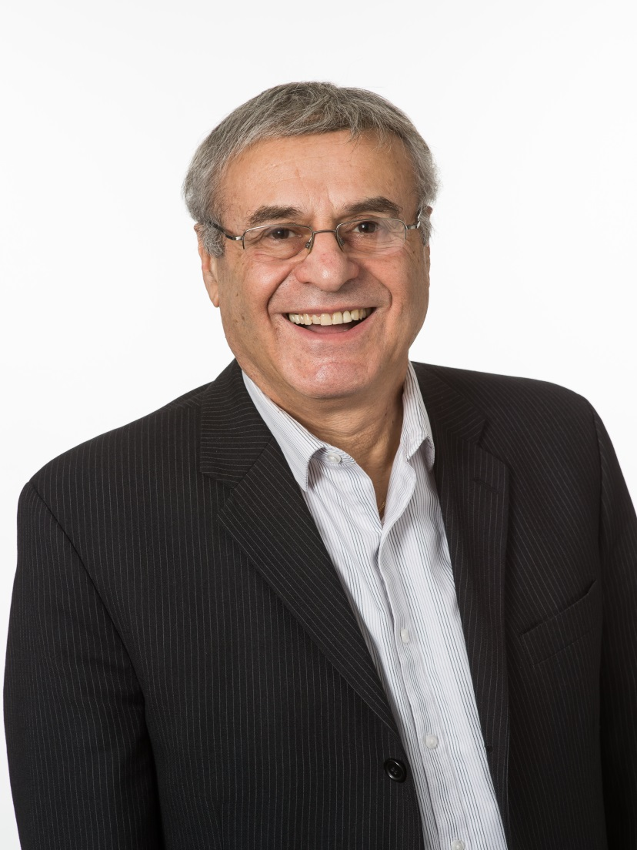  

Middle Eastern Studies Scholar

Associate Member in CMES, UChicago

____________________________________________________

Ph.D., University of Chicago, 1993

______________________________________________________________________________

ADDRESS

644 LaSalle PL

Highland Park, IL 60035

Telephone: (847) 691-1070  
Email: [shai@MEPNetwork.org](mailto:shai@MEPNetwork.org); shaiharel@comcast.net

Website: http:/www.MEPNetwork.org

FIELD SPECIALTIES

Arab-Israeli conflict resolution, Jewish-Muslim reconciliation, Middle Eastern studies

GENERAL BIOGRAPHY

I am a scholar, rabbi, writer, poet, educator, activist, and businessman, whose multi-faceted career spans over fifty years. I was born in Israel, where I lived during my formative childhood and young adulthood, served in the Israeli army, both in active duty (1964-66) and army service (1969-71), and participated in the Six Day War (1967), the War of Attrition (1969-70), and the Yom Kippur War (1973). Over the last thirty-three years, I have been active in building bridges of understanding and reconciliation across the Arab-Israeli and Jewish-Muslim conflict divides. Spending most of my time in the U.S., I have been running the Illinois-based Middle East Peace Network (MEPN), a nonprofit, ambitious, global private diplomacy organization (visit [*www.MEPNetwork.org*](http://www.MEPNetwork.org)), and managing, for over four decades, my financial services firm, Har-El Financial Group (visit [*www.HarelFinancial.com*](http://www.HarelFinancial.com)). I was inducted in 1995 into the Hall of Fame of Equitable Advisors, a national leader in financial protection strategies and wealth management (see *www.equitable.com*), and have received many distinguished awards, most recently the Golden Year Award for achieving 30 years of high-level sales production within the organization. I have also been giving lectures and workshops, and writing essays on Middle East affairs and Jewish spirituality.

ACADEMIC BIOGRAPHY

I attended Tel Aviv University (BA, 1971, and MA, 1976, Department of Middle Eastern and African History), and worked there, in 1970-76, as a Research Fellow at the Shiloah Center (the precursor of the Moshe Dayan Center for Middle Eastern and African Studies), where I ran its Palestinian Desk, and contributed to its Middle East Record publication (see below). I then attended the University of Chicago (PhD, Department of History, 1993), and my doctoral dissertation was published shortly after, and its Turkish translation just recently (see below).

BOOKS

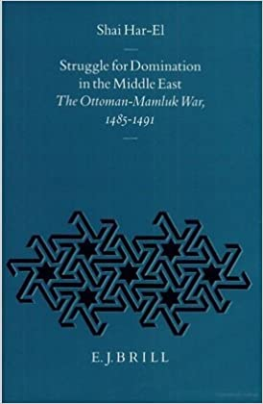 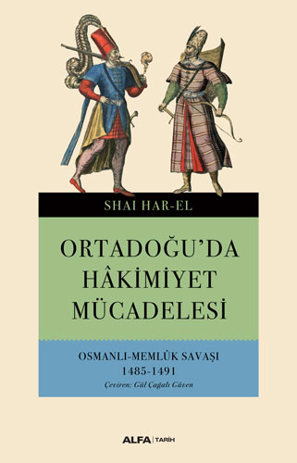

**Shai Har-El** **Shai Har-El**

*Struggle for Domination Ortadoğu'da Hakimiyet*

*in the Middle East: Mücadelesi*

*The Ottoman-Mamluk War Osmanlı Memlük Savaşı*

*(1485-1491 1485-1491*

(Leiden: E.J. Brill, 1995) (Istanbul: Alfa, 2019)

______________________________________________________________________________

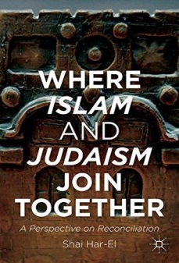

**Shai Y. Har-El**

*Where Islam and Judaism Join Together:*

*A Perspective on Reconciliation*

(New York: Palgrave McMillan, 2014)

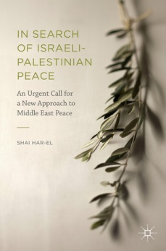

**Shai Y. Har-El**

*In Search for Israeli-Palestinian Peace:*

*An Urgent Call for a New Approach*

*to Middle East Peace*

(New York: Palgrave Macmillan, 2016)

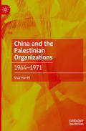

**Shai Y. Har-El**

*[China and the Palestinian Organizations:](https://link.springer.com/book/10.1007/978-3-031-57828-1)*

*1964–1971*

(New York: Palgrave Macmillan, 2024)

SELECTED ESSAYS

I have published over the years numerous essays on current Middle East affairs, focusing on my pursuit of conflict resolution and lasting peace, primarily between Arabs and Israelis and between Muslims and Jews. Here are some:

--“The Palestinian Organizations, 1968” in *Middle East Record*, The Shiloah Center for Middle Eastern and African Studies, Tel Aviv University, vol. 4, 1968.

--“The Palestinian Organizations, 1969-70” and “The United States and the Middle East, 1969-1970,” *ibid*., vol. 5, 1969-1970.

--“Ending the Arab-Israeli Conflict: Time to Seek a New Approach,” Middle East Peace Network (MEPN) publication, 1993.

--“A Quest for Peace,” in *http://www.mepnetwork.org/online-resources/publications/*

--“An Open Letter to My Muslim Friends,” in [*http://www.mepnetwork.org/online-resources/ publications/*](http://www.mepnetwork.org/online-resources/%20publications/)

--“We Are Bound Together:An Appeal to Muslims,” in Shai Har-El, *Where Islam and Judaism Join Together: A Perspective on Reconciliation* (New York: Palgrave Macmillan, 2014), 21-34.

--“From Peace Process to Actual Peace,” *World Policy*, April 3, 2012, in *https://worldpolicy.org/2012/04/03/from-peace-process-to-actual-peace/*

*--*“Sharing Land for Peace: Revisiting Israel-Palestine’s Confederate Future,” *World Policy*, February 5, 2013, in[*http://worldpolicy.org/2013/02/05/sharing-land-for-peace-revisiting-israel-palestines-confederate-future*/](http://worldpolicy.org/2013/02/05/sharing-land-for-peace-revisiting-israel-palestines-confederate-future/)

--“Diagnosing the Israeli-Palestinian Conflict,” *World Policy*, February 20, 2014, in [*http://worldpolicy.org/2014/02/20/diagnosing-the-israeli-palestinian-conflict/*](http://worldpolicy.org/2014/02/20/diagnosing-the-israeli-palestinian-conflict/)

news reports

--“Jews, Arabs Unite in Peace Network,” in *Chicago Tribune*, March 31, 1991.

--“Arabs, Jews Hoping Peace Has a Chance,” in *Chicago Tribune*, October 3, 1993.

--“Seeking Unity in Diversity,” in *The Hammond Times*, December 13, 1993.

--“Islamic Center Hosts a Jewish Speaker,” *Post-Tribune*, December 13, 1993.

--“Jews, Muslims together in sukkah for friendship,” *Highland Park News*, October 11, 2001.

--“Faith to Faith: Engaging Religion in the Middle East Peace Process,” in *https://www.juf.org/pdf/ealert/faith_to_faith.pdf*

--“Islam and Judaism: Time to Tie the Ropes,” April 12, 2014, in

*https://theglobalhuman.wordpress.com/2014/04/12/islam-and-judaism-time-to-tie-the-ropes/amp*/

--“Reconciliation between Judaism and Islam is Possible,” *IslamiCommentary*, May 29, 2014,

and Informed Comment, May, 30 2014, [*https://www.juancole.com/2014/05/reconciliation-judaism-possible.html*](https://www.juancole.com/2014/05/reconciliation-judaism-possible.html)

*--*“Mideast conflict affects all Muslims and Jews: Marmur,” *The Star*, July 20, 2014.

*https://www.thestar.com/opinion/commentary/2014/07/20/mideast_conflict_affects_all_muslims_and_jews_marmur.html*

--“A Time for Israeli-Palestinian Reconciliation,” August, 8, 2014, in

[*https://theglobalhuman.wordpress.com/2014/08/08/a-time-for-israeli-palestinian-reconciliation/*](https://theglobalhuman.wordpress.com/2014/08/08/a-time-for-israeli-palestinian-reconciliation/)

SPIRITUAL WRITINGS

I was ordained as a rabbi in 2012. I have been running workshops and writing on a variety of religious themes, particularly on the interface between Jewish spirituality and personal growth. My forthcoming spiritual self-help book, *Discover the Jewel of Wisdom: Eight Paths to Powerful Living*, is the result of many years of investment in studying, exploring, experiencing, and teaching self-mastery. It is a “living laboratory” report of my own personal findings, while plowing the “fields” of life and my spiritual journey toward rabbinic ordination. My anthology, *Many Ways to Courting God: Selected Spiritual Writings*, and my spiritual guide, *Powerful Living*: A *Daily Spiritual Affirmation Handbook*, were assembled as companion books. My latest inspirational poetry book, *Riding the Waves of Bliss: Seasons of Life* *Poems* (Grants Pass, OR: Homestead Lighthouse Press, 2020), is an insight into the changing seasons of my life. Other recently published poetry books: *A Tale of Two Souls* (Grants Pass, OR: Homestead Lighthouse Press, 2022), and *Yashar MeHalev: Mivchar Shirei Ahava* [Straight from the Heart: An Anthology of Love Poems, in Hebrew] (Israel: Segol Books, 2023).

video INTERVIEWS

--Middle East Peace Network – Overview with Shai Y. Har-El: April 13, 2011 [*https://www.youtube.com/watch?v=F2HUHkP-guI*](https://www.youtube.com/watch?v=F2HUHkP-guI)

--UChicago Alumni Voices: A Path Less Ordinary with Shai Y. Har-El: June 2, 2014

[*https://www.youtube.com/watch?v=O5iZc-9iCgQ&feature=youtu.be*](https://www.youtube.com/watch?v=O5iZc-9iCgQ&feature=youtu.be)

--Highland Park Poetry Today with Shai Y. Har-El: February 20, 2018

*https://www.youtube.com/watch?v=6wymIQxS7lw*